The client model was very easy to implement. It started with a basic TCP client setup and no GUI that acted as a chat client then evolved. It has your basic components:

* Stream Socket for communication. Uses all default properties that comes with a stream socket. It is a client socket. Points towards the InetAddress of the server router and the specified port.
* PrintWriter for writing messages into the socket that will then be sent to the server router.
* BufferReader for reading incoming messages from the server router.

These are the three main components. The other components are supporting components to these three. For phase one of the project we designed the client to read a file then send it line by line to the designated receiver. The receiver takes what is sent, capitalizes it, and then sends it back.

The way the client works is by first connecting to the server router. We use the stream socket to communicate with the server router. The server router IP and Port number are specified in the GUI. The receiver of the file is distinguished by the forwarding IP that is inserted via the GUI. When you click connect the application begins the connection process. It takes in the information passed to it via the GUI and sets IP to connect to and port to use to communicate with the server router. We then set out PrintWriter equal to the socket output stream so we can send messages. Then set the BufferedReader equal to the input stream for incoming messages. If connection is successful, an open file dialog box will appear. Here you can select the file you want to send. As of right now the code is only able to handle plain text. We set a FileReader to read in the file, and then pass it to a BufferedReader so we can read it out line by line to our output stream. The initial send is the address the client is going to pass the file too. The client then waits for a response from the server router verifying we have a good connection. Then the client sends his IP for the server to save for a return address. This is the data that the server router will use in its routing table. We now get into the message passing of the file itself. A timer is started to record cycle times from being sent to server and then back to the client capitalized. This is all outputted to the message text box we created along with the cycle time. In a better break down, we read a line from the file. Then using our print writer outputs the line to the stream. Then the client waits for the capitalized message to come back. This continues until the end of the file. Using a array, all the cycle times are collected. Once the entire file has been transferred and received we output a list of all the times and calculate the total time in milliseconds.

Client Run with a 135kb plaintext file:

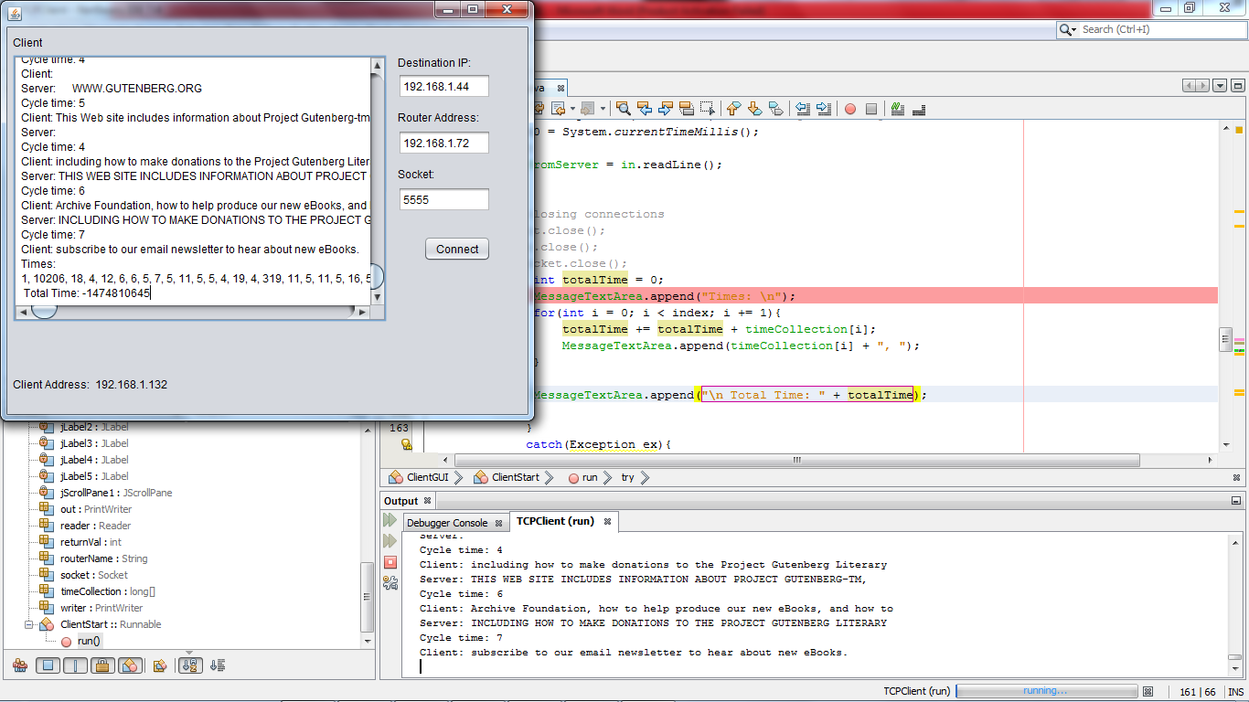

Connecting to Router: 192.168.1.72 Socket: 5555

Connection seccessful

ServerRouter: Connected to the router.

Server: Connected to the router.

Cycle time: 1

Client: The Project Gutenberg EBook of The Pioneer Trail, by Alfred Lambourne

Server: NULLno respon yet.

Cycle time: 10206 initial send. Delay built in router created longer time.

Client:

Server: THE PROJECT GUTENBERG EBOOK OF THE PIONEER TRAIL, BY ALFRED LAMBOURNE

Cycle time: 18

Times in milliseconds:

1, 10206, 18, 4, 12, 6, 6, 5, 7, 5, 11, 5, 5, 4, 19, 4, 319, 11, 5, 11, 5, 16, 5, 8, 6, 10, 6, 4, 8, 7, 6, 5, 6, 5, 4, 5, 5, 5, 6, 5, 4, 9, 13, 9, 7, 5, 5, 9, 5, 4, 4, 7, 5, 6, 6, 4, 5, 5, 6, 5, 10, 7, 5, 6, 4, 6, 5, 5, 6, 5, 5, 6, 6, 4, 6, 3, 5, 5, 5, 7, 5, 5, 17, 7, 5, 8, 4, 6, 6, 5, 5, 5, 5, 4, 5, 10, 11, 4, 6, 4, 6, 8, 5, 4, 5, 4, 5, 6, 5, 6, 4, 10, 4, 6, 5, 8, 5, 3, 6, 5, 5, 6, 5, 5, 8, 4, 5, 14, 5, 5, 5, 6, 4, 5, 6, 7, 4, 5, 5, 3, 6, 5, 5, 3, 4, 6, 5, 4, 6, 3, 7, 4, 5, 13, 8, 5, 5, 7, 4, 4, 5, 5, 7, 5, 5, 4, 7, 4, 5, 6, 6, 4, 5, 4, 4, 8, 5, 5, 5, 4, 4, 6, 5, 4, 4, 4, 5, 3, 4, 6, 15, 3, 5, 4, 7, 4, 4, 4, 4, 9, 6, 4, 6, 6, 10, 5, 5, 4, 5, 4, 6, 4, 7, 4, 5, 4, 4, 5, 6, 4, 6, 4, 5, 5, 5, 7, 4, 4, 4, 4, 5, 6, 4, 6, 6, 10, 6, 3, 5, 7, 5, 4, 5, 4, 5, 3, 6, 4, 5, 7, 4, 5, 5, 3, 6, 5, 4, 4, 9, 4, 10, 4, 5, 4, 4, 4, 4, 9, 4, 5, 5, 5, 7, 6, 5, 5, 4, 5, 7, 9, 5, 6, 4, 6, 4, 5, 4, 5, 5, 4, 8, 5, 4, 3, 5, 6, 4, 8, 4, 3, 5, 5, 5, 5, 7, 5, 5, 4, 4, 8, 5, 6, 5, 7, 4, 4, 7, 6, 5, 5, 6, 6, 7, 4, 12, 5, 6, 6, 4, 4, 7, 4, 4, 8, 4, 17, 5, 6, 5, 6, 4, 11, 6, 5, 4, 9, 3, 5, 7, 5, 6, 4, 4, 6, 7, 5, 4, 5, 5, 23, 17, 7, 7, 9, 11, 6, 21, 5, 5, 6, 6, 10, 5, 6, 4, 5, 5, 5, 7, 4, 4, 4, 4, 6, 6, 4, 5, 5, 5, 6, 4, 5, 6, 6, 4, 5, 4, 5, 8, 5, 4, 5, 4, 7, 5, 4, 5, 4, 7, 4, 3, 6, 4, 6, 5, 4, 4, 5, 7, 5, 4, 6, 4, 8, 5, 5, 4, 5, 6, 8, 20, 6, 4, 4, 8, 4, 4, 4, 11, 13, 4, 6, 4, 5, 6, 4, 5, 6, 5, 5, 8, 4, 7, 5, 6, 6, 5, 4, 5, 6, 6, 5, 5, 5, 3, 6, 4, 6, 7, 4, 5, 4, 4, 7, 12, 4, 4, 7, 5, 7, 4, 134, 4, 4, 4, 4, 6, 5, 4, 5, 6, 6, 4, 5, 11, 4, 5, 4, 6, 4, 5, 235, 323, 49, 4, 7, 5, 6, 6, 7, 4, 6, 6, 230, 327, 18, 5, 6, 6, 5, 4, 7, 7, 4, 5, 7, 8, 3, 4, 4, 117, 5, 5, 4, 12, 5, 9, 12, 10, 6, 5, 7, 6, 6, 7, 230, 336, 7, 12, 5, 4, 6, 5, 5, 11, 5, 4, 8, 5, 4, 4, 231, 4, 11, 6, 7, 5, 5, 5, 6, 4, 4, 4, 3, 7, 5, 4, 7, 231, 3, 213, 4, 8, 21, 5, 7, 5, 6, 8, 6, 4, 7, 4, 7, 4, 235, 6, 16, 11, 7, 14, 3, 14, 5, 4, 4, 233, 32, 6, 18, 4, 4, 5, 5, 4, 4, 4, 6, 4, 4, 7, 4, 4, 3, 161, 4, 7, 10, 6, 6, 5, 4, 6, 8, 4, 5, 5, 4, 4, 4, 6, 258, 178, 7, 4, 6, 4, 9, 6, 4, 5, 5, 4, 3, 5, 4, 6, 4, 6, 6, 5, 4, 6, 5, 5, 4, 4, 5, 5, 4, 3, 5, 4, 4, 6, 4, 4, 5, 4, 5, 6, 4, 5, 7, 5, 5, 4, 6, 4, 7, 4, 4, 4, 6, 5, 6, 5, 5, 4, 4, 6, 5, 3, 7, 7, 5, 4, 4, 5, 5, 4, 5, 6, 6, 6, 6, 4, 5, 3, 6, 4, 3, 7, 4, 6, 4, 4, 5, 6, 4, 4, 4, 4, 4, 5, 4, 4, 4, 5, 5, 6, 4, 5, 6, 6, 10, 4, 5, 4, 7, 5, 5, 6, 3, 4, 7, 5, 15, 5, 7, 4, 10, 6, 5, 4, 6, 4, 5, 4, 5, 5, 5, 4, 6, 5, 5, 4, 3, 7, 4, 7, 4, 8, 4, 7, 15, 12, 25, 8, 4, 5, 5, 6, 6, 9, 5, 8, 6, 4, 6, 5, 4, 5, 6, 4, 5, 6, 6, 6, 5, 9, 13, 7, 6, 23, 6, 4, 3, 6, 5, 5, 5, 4, 6, 3, 7, 10, 6, 5, 6, 7, 6, 4, 23, 4, 4, 4, 11, 4, 4, 4, 4, 5, 6, 6, 14, 6, 5, 5, 6, 4, 5, 5, 4, 10, 6, 4, 5, 6, 3, 11, 5, 5, 8, 4, 4, 8, 7, 4, 5, 4, 4, 5, 9, 3, 4, 5, 4, 4, 4, 4, 6, 6, 4, 4, 7, 5, 4, 9, 4, 13, 9, 6, 5, 5, 4, 10, 7, 4, 5, 9, 5, 5, 3, 5, 4, 4, 4, 4, 5, 4, 5, 5, 5, 4, 5, 7, 4, 5, 6, 4, 6, 5, 4, 5, 5, 4, 4, 4, 4, 4, 6, 4, 4, 4, 8, 7, 5, 4, 7, 5, 4, 4, 3, 5, 5, 10, 4, 4, 5, 5, 6, 4, 6, 5, 7, 4, 4, 6, 4, 4, 4, 5, 5, 5, 4, 4, 4, 4, 4, 9, 5, 4, 4, 5, 13, 4, 5, 7, 4, 4, 4, 5, 4, 5, 7, 4, 5, 4, 4, 5, 4, 5, 5, 8, 4, 14, 6, 5, 4, 4, 5, 13, 4, 4, 6, 3, 5, 4, 4, 4, 8, 4, 5, 6, 5, 9, 9, 4, 6, 3, 4, 4, 3, 5, 4, 4, 4, 5, 9, 4, 4, 6, 8, 3, 5, 4, 4, 5, 8, 4, 4, 4, 11, 6, 4, 4, 5, 15, 6, 5, 5, 4, 5, 4, 5, 4, 4, 4, 4, 6, 5, 6, 5, 5, 6, 7, 3, 4, 7, 5, 4, 6, 4, 4, 5, 7, 4, 5, 4, 5, 6, 4, 6, 5, 4, 5, 6, 5, 8, 5, 6, 4, 5, 4, 5, 6, 5, 5, 6, 9, 6, 4, 4, 5, 7, 4, 4, 9, 4, 5, 5, 7, 6, 4, 6, 4, 5, 19, 5, 5, 7, 4, 5, 9, 6, 4, 5, 4, 8, 6, 4, 6, 5, 7, 6, 5, 4, 5, 6, 5, 5, 9, 4, 4, 6, 4, 6, 6, 5, 5, 5, 6, 5, 5, 6, 8, 6, 3, 5, 5, 11, 4, 13, 6, 3, 4, 4, 5, 4, 5, 5, 4, 3, 4, 7, 4, 5, 7, 5, 4, 9, 4, 5, 4, 5, 4, 5, 4, 4, 4, 5, 4, 4, 5, 6, 4, 4, 6, 5, 6, 4, 4, 5, 5, 5, 4, 6, 4, 17, 4, 4, 4, 4, 6, 5, 4, 5, 5, 4, 6, 5, 6, 6, 9, 5, 5, 5, 9, 4, 3, 4, 7, 13, 7, 3, 4, 3, 4, 11, 4, 5, 4, 5, 4, 7, 3, 5, 4, 4, 5, 3, 5, 7, 5, 5, 3, 4, 4, 4, 4, 9, 6, 4, 4, 4, 6, 5, 6, 6, 4, 5, 7, 4, 5, 4, 5, 4, 5, 5, 4, 5, 4, 5, 5, 4, 5, 5, 5, 4, 8, 5, 6, 4, 4, 4, 5, 5, 4, 10, 4, 4, 4, 8, 5, 6, 8, 4, 11, 3, 6, 5, 4, 4, 4, 5, 4, 6, 4, 5, 4, 5, 4, 5, 4, 5, 5, 5, 7, 5, 8, 4, 6, 10, 4, 3, 6, 6, 5, 4, 4, 7, 8, 4, 5, 7, 4, 4, 7, 5, 4, 4, 5, 7, 6, 5, 8, 4, 4, 7, 5, 6, 5, 8, 4, 5, 6, 5, 6, 3, 4, 4, 4, 8, 3, 4, 9, 7, 4, 4, 4, 5, 6, 5, 4, 8, 5, 5, 5, 7, 4, 4, 5, 4, 4, 5, 5, 9, 4, 5, 4, 36, 6, 4, 5, 4, 5, 4, 4, 6, 5, 4, 4, 5, 5, 7, 4, 4, 6, 4, 5, 4, 4, 5, 4, 5, 4, 5, 4, 4, 5, 6, 5, 4, 5, 14, 6, 7, 5, 4, 6, 4, 11, 3, 4, 4, 4, 5, 8, 3, 5, 4, 5, 13, 8, 4, 5, 4, 5, 5, 3, 4, 4, 5, 4, 5, 4, 5, 4, 8, 6, 7, 4, 4, 10, 4, 4, 4, 4, 5, 5, 3, 4, 4, 3, 4, 5, 4, 4, 9, 5, 6, 3, 4, 6, 4, 4, 3, 4, 4, 5, 6, 4, 5, 5, 4, 4, 3, 5, 5, 5, 4, 6, 4, 5, 11, 7, 5, 3, 5, 5, 4, 6, 5, 5, 8, 4, 5, 5, 6, 6, 3, 5, 6, 4, 6, 4, 4, 4, 4, 5, 6, 4, 4, 4, 4, 4, 5, 6, 4, 4, 4, 6, 5, 4, 6, 4, 6, 3, 4, 4, 4, 5, 4, 4, 5, 4, 8, 4, 4, 12, 7, 4, 6, 5, 5, 4, 4, 4, 5, 5, 8, 4, 4, 4, 4, 4, 5, 4, 5, 4, 4, 6, 6, 4, 5, 4, 5, 4, 5, 4, 4, 4, 5, 4, 4, 6, 4, 6, 3, 5, 6, 4, 4, 4, 6, 5, 6, 4, 4, 5, 3, 4, 5, 5, 4, 4, 5, 5, 5, 4, 5, 4, 6, 7,

Total Time: -1474810645 milliseconds